What is a paradigm shift?

A discussion of whether John Dalton’s
theory of atomic structure merits this description.

Internal Assessment submission
for the
International Baccalaureate
Nature of Science Course

Introduction

The name most commonly linked with atomic theory is that of John Dalton, an English chemist who lived and worked in Manchester around about 1800, though almost all references also mention the ancient Greek, and in particular a philosopher called Democritus.
Dalton’s atomic theory is frequently referred to as a paradigm shift. A paradigm is a set of fundamental assumptions, made by academics working in a particular area, that are not usually questioned. This term “paradigm shift” was introduced in 1962 by Thomas Kuhn in his book “The Structure of Scientific Revolutions” (1962)⁽¹⁾, to refer to a sudden change in the basic assumptions governing a particular field of science, though in the case of atomic theory the change is so fundamental that it is difficult to think of a field of science it has not affected. A paradigm shifts occur over a short period of time between phases of steady scientific progress within a particular paradigm (Kuhn’s “normal science”) and they tend to be opposed by scientists working in the preceding paradigm, so they are not fully accepted until these people have ceased to be active.
This investigation will consider whether Dalton’s atomic theory was really a “paradigm shift” through a review of the work being done in the European chemical community during that period and the concepts that this was generating amongst Dalton’s contemporaries.

Democritus and the Ancient Greeks

Before investigating Dalton and his contemporaries I will briefly consider Democritus and the extent to which his atomic theory was scientific and hence is comparable to that of Dalton.
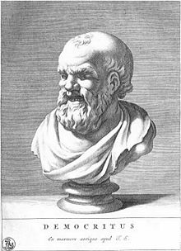
Democritus, who lived around 400 BCE, was not the only person in Ancient Greece who believed in atoms as a question that was frequently pondered by philosophers of that period was what would happen if one continued to split an object (like a stone) in two. One group of philosophers, of which Democritus is the one most familiar in the modern world, considered that there would come a point at which it could no longer be further divided. These philosophers, known as “atomists” (atomon in Greek means “uncuttable” or “indivisible”) believed that each substance was made of very small particles, which were all the same, but different to the basic particles of other substances. A second group of philosophers, of whom Aristotle was probably the most influential member, believed that you would be able to continue to divide an object in two an infinite number of times – a limit would never be reached.
A corollary of the concept of atoms is that between them must exist a void and this appears to be the feature of atoms that other philosophers found most disturbing (Plato disliked the philosophy of Democritus so much that he wished for all his books to be burned!⁽²⁾) and neither side could cite evidence that backed their view of the fundamental nature of matter, hence the question could not be resolved. Democritus and his students describe how the shapes of molecules might influence the properties of materials, but this was done by projecting backwards how the observed properties of materials might be linked to some kind of particle shape (“water atoms are smooth and slippery”), the exact opposite of the scientific method of working upwards to demonstrate how the physical properties of matter arose from some proven characteristic of the atoms that comprised them.
One important aspect of scientific thinking, as propounded by Karl Popper in Conjectures and Refutations⁽³⁾, is falsification - that scientific thinking should be testable and hence capable of being disproved. It can be seen that as Democritus’ atomism arose as a purely hypothetical concept, a conjecture of abstract thought, rather than arising from consideration of particular empirical evidence, hence it is probably better regarded as philosophical rather than scientific.
Often however the esteem a person is held in, even in science, means that concepts that they endorse take on a prestige beyond the underlying evidence. Aristotle was such a major influence on the scientific community for about two millennia after his death that the very fact that he considered atomism to have little merit meant that it disappeared from Western thinking for many centuries.

The Alchemists

As noted above, atomism was largely ignored in the Western world (though it did continue to develop through various sects of Eastern religions) for about 2000 years from the time of Democritus. Chemistry in this time was largely dominated by alchemists searching for the Elixir of Life and the Philosopher’s Stone. This was based on Aristotle’s theory that all things were composed of just four elements (earth, air, fire and water).⁽⁴⁾ One group of alchemists, known as the “corpuscularians” believed that the constituent elements of a substance were combined together in a corpuscle and this made its properties very different to those of the constituent elements. In this way their thoughts to an extent anticipated the molecules of modern chemical theory.

Robert Boyle⁽⁵⁾
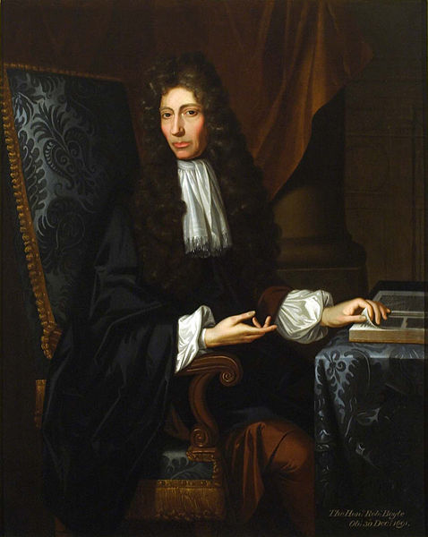
Robert Boyle whose work started out, and largely remained, in the tradition of corpuscularian alchemy (he made repeated attempts to transmute base metals to gold), also showed many facets of a modern scientist, such as taking quantitative measurements (hence Boyle’s Law regarding the relationship between the pressure and volume of gases). In 1661 he published one of the ground-breaking books in Chemistry - “The Sceptical Chymist”⁽⁶⁾. Scepticism is an important attribute of the scientist – the desire to examine the underlying evidence rather than just trusting the word of previous generations. In this book he parts from classical Aristotelian concepts, clearly distinguishes between mixtures and compounds (“perfectly mixt’ elements”)⁽⁷⁾ and anticipates kinetic theory by proposing that changes occur as a result of collisions between particles in motion. He even hints at the difference between atoms and molecules:
“There are Clusters wherein the Particles stick not so close together, but that they may meet with Corpuscles of another Denomination, which are dispos'd to be more closely United with some of them, than they were among themselves.”
Through the success of “The Sceptical Chymist” the concept that matter is composed of minute particles was once again opened up for discussion after the mental block imposed by acceptance of Aristotelian concepts. In spite of Boyle’s “modern” concepts little progress was made for about a century, whilst Chemistry in Western Europe was diverted by the hypothesis of phlogiston and its eventual denunciation. In Russia however further progress was being made…….

Mikhail Lomonosov
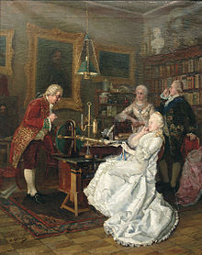
Lomonosov (shown on the left being visited by Catherine II) was also a Geographer, postulating ideas similar to the theory of continental drift, as well as being an accomplished poet and artist, principally in the medium of mosaics which arose from experiments in glass making. He was aware of Boyle’s work, showing that even in those days communication was an essential part scientific investigation. Another essential element of scientific methodology is repeating the work of others to check their findings – falsification being a critical element of scientific progress. Around 1750 Lomonosov was repeating Boyle’s experiments regarding mass changes resulting from the combination of tin and of lead with air. The data he obtained led him to postulate the conservation of mass:⁽⁸⁾
“... made experiments in ﬁrmly sealed glass vessels in order to investigate whether the weight of metals increases from pure heat. It was found by these experiments that the opinion of the famous Robert Boyle is false, for without letting in the external air the weight of the ignited metal remains in the same measure...”
Lomonosov however embraced many of Boyle’s other ideas and extended some of them, for example agreeing with him that that all matter is composed of corpuscles (which Lomonosov later refers to as particles, or molecules) that are "collections" of elements (which he later refers to as atoms). Indeed some of his definitions sound quite contemporary:
"An element is a part of a body that does not consist of any other smaller and different bodies ... a corpuscle is a collection of elements forming one small mass."

Antoine Lavoisier⁽⁹⁾

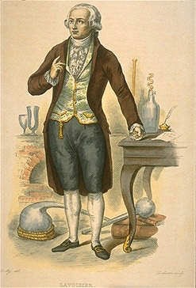
Science is intimately linked with the methodology of experimentation and Lavoisier was a first class experimental chemist. By carefully weighing the reactants and products of chemical reactions in a sealed glass vessel he established that, although matter can change its state and appearance, the total mass at the end is the same as at the beginning. It is unclear whether he was familiar with Lomonosov’s work and even if he was an important aspect of scientific investigation is to take a concept and test it in a wider range of situations to se if it has limitations and he certainly investigated a much wider range of reactions from the reaction of mercury with air to the rotting of fruit. The results he obtained supported the conservation of mass, which is known in France as Lavoisier’s Law.
Perhaps an even greater contribution to Chemistry was the publication in 1789 of his “Traité Élémentaire de Chimie”, probably the best Chemistry text book written up till that time. In this he clearly set out this principle and many other modern chemical ideas, but perhaps more importantly in the long term he introduced a new, more rational nomenclature (for example “copper sulphate” instead of “vitriol of Venus”). The importance of the language of science cannot be underestimated as it must be clear, unambiguous and clearly reflect the concepts of the day.
Lavoisier was very consciously an empiricist:⁽¹⁰⁾
"I have tried to arrive at the truth by linking up facts; to suppress as much as possible the use of reasoning, which is often an unreliable instrument which deceives us, in order to follow as much as possible the torch of observation and of experiment."
By “reasoning” here one assumes Lavoisier means open-ended speculation that is not based on results, in contrast to that which is based on the interpretation of experimental data.
As is frequently the case scientific progress was affected by the political factors and Lavoisier’s contributions after the publication of “Traité Élémentaire de Chimie” were probably limited by the French Revolution. Not only was Lavoisier from a noble background, but he was also involved in a tremendously unpopular tax organisation, the Ferme Générale. He was gradually forced to resign from his various posts, in late 1793 he was arrested and died at the guillotine in May 1794, curtailing possible further scientific achievements. If spared by the revolution, would Lavoisier have come up with an Atomic Theory?

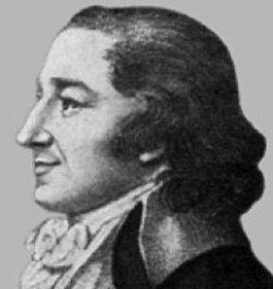
Jeremias Richter⁽¹¹⁾
In Germany, around 1790, Jeremias Richter was working on quantitative measurements concerning the neutralisation reactions of acids and bases. One of his strengths was the improvement of experimental methods, something that is critical for the progress of science through greater precision and reliability of experimental data. Many of the techniques that he developed are still familiar in modern day titrations. He found that the ratio of the masses of two substances which react with each other is always fixed, the basis of what we now know as the law of definite proportions. For example he determined that it always took 615 parts by weight of magnesium oxide to neutralize 1000 parts by weight of sulphuric acid. It was Richter too, who first introduced the term “stoichiometry”, another important addition to the language of Chemistry.
The unfortunate thing about Richter’s work was that it was presented in a very obscure, mathematical way showing that scientific communication, the way in which ideas are presented, is absolutely critical to progress. Fortunately he was soon followed by other workers, such as Proust, who carried out similar work on other systems and presented their ideas more clearly. Hence, as often happens in science, his contribution was not truly recognised until many years after his death.

Joseph Proust⁽¹²⁾
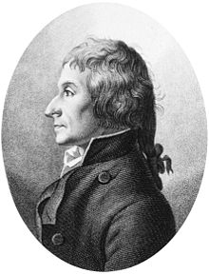
Proust, like his better known literary namesake, was born in France, though he worked for most of his life in Spain. His analyses of metal oxides, hydroxides, carbonates and sulphides in the late 1790s supported the law of definite proportions, which is sometimes referred to as Proust’s Law. In his own words:
“We must recognize an invisible hand which holds the balance in the formation of compounds. A compound is a substance which Nature assigns fixed ratios.”
In science there are often differing opinions and Proust’s conclusions were opposed by Claude Louis Berthollet who cited the variable composition of copper and tin oxide minerals. Scientific method however provides a route to resolve these differences and, by means of more precise experiments, Proust showed that some of these were mixtures of two distinct oxides whilst others contained water combined into the crystal structure. Berthollet is however commemorated by the naming of a more recently discovered class of true non-stoichiometric compounds as Berthollite compounds.
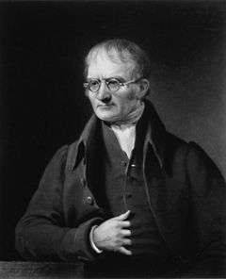
John Dalton⁽¹³⁾⁽¹⁴⁾

John Dalton was born in Kendal, in 1766, and educated there, but carried out most of his work in Manchester. His early interest was in meteorology, which then extended to an interest in the properties of gases resulting in his partial pressure law, proposed in 1803.
Dalton then turned his attention to the composition of the atmosphere, from which eventually led to his proposal of the law of multiple proportions. This extended the law of definite proportions to the ratio of elements present when the combining elements can form more than one compound. Along with the law of constant mass and law of definite proportions it provided a key piece of evidence regarding atomic theory. His own 1805 account of one experiment (with some bold
explanatory notes) reads:⁽¹⁵⁾
“If 100 measures of common air (contained over water) be put to 36 of pure nitrous gas (NO), after a few minutes the whole will be reduced to 79 or 80 measures (just nitrogen as all the oxygen has reacted, then the acidic oxides reacted and dissolved in the water), and exhibit no signs of either oxygenous (O₂) or nitrous gas. If 100 measures of common air be admitted to 72 of nitrous gas there will, as before, be found 79 or 80 measures of pure azotic gas for a residuum. These facts clearly point out the theory of the process: the elements of oxygen may combine with a certain portion of nitrous gas (NO + ½ O₂ → NO₂), or with twice that portion. (2NO + ½ O₂ → N₂O₃), but with no intermediate quantity.”
In other words one oxygen can combine with either two or four nitrogen monoxides – if less than 36, or more than 72, measures of nitrogen monoxide is used there will be a greater volume of gas remaining because one of the two reactant gases will remain in excess. Amazingly these results appeared as almost a footnote to his investigation of the gases present in the atmosphere!
Scientists often need informal discussion to help clarify their ideas and Dalton put forward the basic tenets of his atomic theory in discussions with a friend in 1804, but it was not until 1808 that he was ready to communicate these to the scientific world in general through his landmark publication ”A New System of Chemical Philosophy”.⁽¹⁶⁾ One wonders whether the use of the term “Chemical Philosophy” indicates that Dalton had some insight into the impact of his theory. The five basic principles he proposed were:
- Elements are made of extremely small particles called atoms.
- Atoms of a given element are identical in size, mass, and other properties; atoms of different elements differ in size, mass, and other properties.
- Atoms cannot be subdivided, created, or destroyed.
- Atoms of different elements combine in simple whole-number ratios to form chemical compounds.
- In chemical reactions, atoms are combined, separated, or rearranged.
This provided a clear conceptual explanation for the laws of conservation of mass and definite proportions, as well as Dalton’s own law of multiple proportions. It also had innumerable, far reaching implications which were open to experimental verification – another critical aspect of a scientific theory. The strength of this interpretation is reflected in the fact that even today Dalton’s concepts underpin most chemical thinking. Dalton did however make a mistake in his sixth principle:
- It must be presumed that when atoms combine in only one ratio, this is a binary one, unless some cause appear to the contrary.
As far as can be seen Dalton had no evidence for this, showing that even the best minds can go astray once they deviate from scientific method into speculation. It was necessary to make some assumption because at that time there was no evidence relating to the numbers of atoms combining, only the combining masses. Dalton was probably simply applying Occam’s razor (why make things more complicated than they need to be) and, as is usually the case in science, oversimplifications are revealed through empirical data that cannot be explained. If the sixth principle were correct then, for example water would be HO, not H₂O, and would have a relative molecular mass of 17 not 18. Dalton’s sixth principle also inevitably led to mistakes in the relative masses of atoms and first set of values he published were:
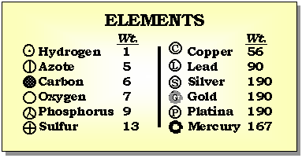

The effect of the sixth principle is obvious with oxygen, which has a valency of two, being approximately half the currently accepted value and nitrogen, with a valency of three, about one third. This also applies to sulphur and phosphorus, their equivalents in the period below, whilst the metals in the right hand column show large aberrations. Whilst these are significant errors, Dalton’s published theory provided an excellent framework within which others could frame experiments to test and improve it.
Joseph Gay-Lussac⁽¹⁷⁾
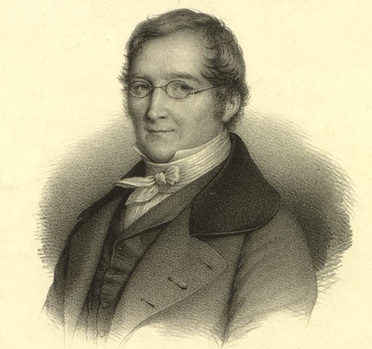
Gay-Lussac was a French chemist whose initial work involved studying the relationship of the pressure, temperature and volume of a fixed mass of gas; indeed Charles’ law is only named as such because Gay-Lussac recognised his prior, unpublished work in the field. He then moved on to investigate the combining volumes of gases, apparently totally unaware of the very similar investigations being carried out by Dalton. It is often the case that the scientific climate of the times leads scientists to carry out closely related investigations at a similar time. Sometimes this can be beneficial to science as their work corroborates each others and may even indicate the limitations of slightly different methods. In other cases it can do the opposite as it frequently leads to disputes about precedence, for example the relationship between pressure and volume of a fixed mass of gas at constant temperature is known as Boyle’s Law in the English speaking world and Mariotte’s Law in the French speaking world (Gay-Lussac’s recognition of Charles’ prior work is the exception rather than the rule!).
As a result of his studies, initially on hydrogen-oxygen mixtures but later extended to mixtures of other gases, Gay-Lussac propounded the law that bears his name, which states that when gases combine the volumes in which they do so, measured at the same temperature and pressure, are in a simple ratio. This provided further direct support for Dalton’s model, especially when combined with the hypothesis of Italian chemist Amedeo Avogadro, proposed in 1811, that the same volume of any gas, at a given temperature and pressure, contains the same number of gas particles. In spite of this Dalton distrusted, and probably never fully accepted, Gay-Lussac's results or conclusions. The reasons for Dalton’s attitude are not clear but it may just be an issue of professional jealousy (it is said that Gay-Lussac was a much more precise experimenter) - a human trait from which scientists are certainly not immune! This may also explain Dalton’s reaction to Berzelius’ chemical notation.

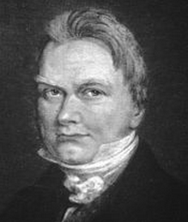
Jöns Jacob Berzelius⁽¹⁸⁾

Berzelius, a Swedish chemist, published a table of relative atomic masses in 1818. This work provided strong support for Dalton’s theory. Berzelius, through ongoing experimentation, gradually refined his values and those he published in 1826, shown below, are remarkably close to values accepted today, though there are obvious mistakes with sodium, potassium and silver, arising from erroneous assumptions about their valency. This is another important facet of science, the way that through critical review of the techniques used and the precision of the results obtained, scientists can refine their methods and improve their results. Berzelius’ main research was however in electrochemistry and, by applying these techniques, he and his team isolated six new elements. Simple, universally accepted, easily applied notation is vital to clear communication in science, so arguably Berzelius’ greatest contribution to chemistry was the system of one or two letter symbols for every element, which can be used to represent chemical formulae and hence construct equations. Dalton however always objected to this chemical notation, although most thought it was much simpler and more convenient than his own cumbersome system of circular symbols.

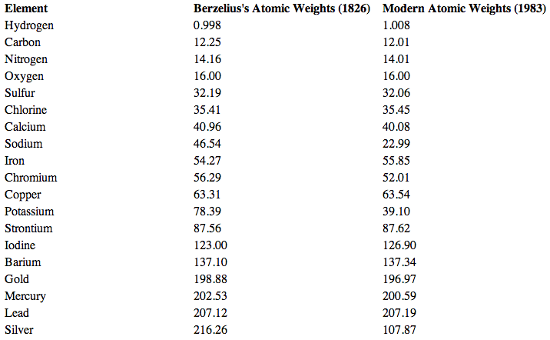
Berzelius’ 1826 table of relative atomic masses ⁽¹⁹⁾

Conclusion

Firstly it can be seen from the account above that the atomism of Dalton differs totally from that of Democritus in that it Democritus only favoured this as one of two logical alternatives to the continual subdivision of matter, but there was no empirical proof available for his hypothetical assertion. In contrast Dalton proposed his atomic theory as a way of explaining the many experimental results obtained both by himself and by other chemists. Dalton’s atomic theory is clearly in the field of science, whereas that of Democritus belongs more to philosophy.
Secondly there is the question about whether it is justifiable to refer to Dalton’s atomic theory as a paradigm shift. The idea that matter was composed of minute particles had been in existence since the time of the corpuscularian so this aspect of atomic theory was not revolutionary. In addition Robert Boyle clearly believed that these particles could combine together to produce compounds. If the mass of these particles did not vary, a reasonable a priori assumption, then the conservation of mass would follow, but the empirical confirmation of this by Lomonosov and Lavoisier was nevertheless vital. The establishment of the law of definite proportions by Richter and Proust would indicate that the particles involved had different masses, though neither seems to have taken the mental leap of interpreting their results in terms of sub-microscopic particles. Dalton, after extending their observations into his law of multiple proportions, then took the enlightened step of linking the empirical evidence about their combining masses with the concept particles and came to the realisation that the latter could readily explain the former. Hence what Dalton did was to link together ideas that were already well accepted by the scientific community of the age and describe how one could explain the other.
Whilst there is no doubt that Dalton’s proposal of the atomic theory marks a major turning point in the way that scientists view the world around them, on the whole I do not consider that Dalton’s atomic theory fits the overall pattern of a paradigm shift. Dr. Jon Hunner, a science historian, also considers atomic theory in the context of paradigms and paradigm shifts.⁽²⁰⁾ Though he does not say so directly I believe that he too is of the opinion that whilst atomic theory undoubtedly defines a paradigm, it did not displace a prior paradigm, hence it cannot be regarded as a true paradigm shift. It did not involve any novel concepts, nor did it represent a sudden departure in thinking from his contemporaries. As a result there seems to be little evidence of any significant opposition to the theory, though one of the weaknesses of a historical topic is that material expressing contrary opinions may not have survived until the present day. Indeed one problem of this, and any historic investigation is the limited primary resources that survive. Dalton’s atomic theory is best seen as the culmination of the work of many chemists, over about sixty years, in a wide variety of European countries - a wonderful example of international cooperation and the sharing of scientific knowledge. Models are absolutely critical to our understanding of the world through science and what Dalton did was to very creatively propose a model that not only neatly explained the observations of the chemists of his era, but has largely stood the test of time to essentially encapsulate the thinking of chemists two hundred years later.
It would be of interest to carry out a detailed comparison of Dalton’s atomic theory to Einstein’s theory of relativity, the archetypal paradigm shift, to more closely investigate ways in which they differ. There are many other alleged paradigm shifts, such as plate tectonics, which could be investigated to see if this classification is justified
References

(1) Thomas S. Kuhn “Structure of Scientific Revolutions”, The University of Chicago Press, 1962
https://www.lri.fr/~mbl/Stanford/CS477/papers/Kuhn-SSR-2ndEd.pdf

(2) R. Ferwerda “Democritus and Plato”, in Mnemosyne, Fourth series, Vol. 25, 1972 http://www.jstor.org/discover/10.2307/4430143?sid=21105518175133&uid=3738776&uid=4&uid=2

(3) Karl Popper, Conjectures and Refutations, London: Routledge and Keagan Paul, 1963 http://worthylab.tamu.edu/Courses_files/Popper_ConjecturesandRefutations.pdf

(4) Khan Academy, From Alchemy to Chemistry, https://www.khanacademy.org/partner-content/big-history-project/stars-and-elements/other-material3/a/from-alchemy-to-chemistry ; Accessed 22-Dec-2013

(5) Robert Boyle in the Standford Encyclopedia of Philosophy, http://plato.stanford.edu/entries/boyle/ ; Accessed 22-Dec-2013

(6) Robert Boyle, The Sceptical Chymist, 1661 http://www.gutenberg.org/ebooks/22914

(7) “Who was the first to classify materials as compounds?”, General Chemistry Online, http://antoine.frostburg.edu/chem/senese/101/matter/faq/who-defined-compounds.shtml ; Accessed 22-Dec-2013

(8) L. B. Okun, The Evolution of the Concepts of Energy, Momentum and Mass from Newton and Lomonosov to Einstein and Feynman, http://www.itep.ru/theor/persons/lab180/okun/em_28.pdf ; Accessed 22-Dec-2013

(9) Chemistry in History, Early Chemistry and Gases, Antoine Lavoisier, http://www.chemheritage.org/discover/online-resources/chemistry-in-history/themes/early-chemistry-and-gases/lavoisier.aspx ; Accessed 22-Dec-2013

(10) Eric Weisstein’s World of Biography, Antoine Lavoisier, http://scienceworld.wolfram.com/biography/Lavoisier.html ; Accessed 22-Dec-2013

(11) Dead Scientist of the Week, Jeremias Richter, http://deadscientistoftheweek.blogspot.co.nz/2013/03/jeremias-b-richter.html ; Accessed 22-Dec-2013

(12) Nautilus biographies, Joseph Proust - http://nautilus.fis.uc.pt/st2.5/scenes-e/biog/b0059.html ; Accessed 22-Dec-2013

(13) Arthur Bower Griffiths, Biographies of Scientific Men - John Dalton ; http://en.wikisource.org/wiki/Biographies_of_Scientific_Men/Dalton

(14) Agnes Mary Clerke in Dictionary of National Biography, 1885-1900, Volume 13, Dalton, John (1766-1844) ; http://en.wikisource.org/wiki/Dalton,_John_(1766-1844)_(DNB00)

(15) Memoirs of the Literary and Philosophical Society of Manchester 1, 244-58 (1805) ; http://web.lemoyne.edu/~giunta/DALTON1.HTML

(16) John Dalton, ”A new system of chemical philosophy”, William Dawson & Son Ltd, London 1808 ; https://archive.org/details/newsystemofchemi01daltuoft

(17) The 1902 encyclopaedia, Gay-Lussac, http://www.1902encyclopedia.com/G/GAY/joseph-louis-gay-lussac.html ; Accessed 22-Dec-2013

(18) Chemistry in History, Electrochemistry, Berzelius, http://www.chemheritage.org/discover/online-resources/chemistry-in-history/themes/electrochemistry/berzelius.aspx ; Accessed 22-Dec-2013

(19) Purdue University, Chemical Education Faculty, http://chemed.chem.purdue.edu/genchem/history/berzelius.html; Accessed 22-Dec-2013

(20) Jon Hunner, J. Robert Oppenheimer, the Cold War and the Atomic West, p 33-34, University of Oklahoma Press, 2009 ; https://books.google.co.uk/books?isbn=0806185775

NOS - IA Exemplar 9 B:
The Foundations of Atomic Theory
Context  x/6 | Strategy  x/6 | Analysis  x/6 | Evaluation  and Conclusion  x/6 | Scientific Communication and Engagement  x/4 | Total  x/28
6 | 4 | 5 | 5 | 4 | 24

Context
Mark | Descriptor
5 - 6 | - Constructs a relevant and coherent research topic and focuses it on the NOS aspects.  - Discusses the relevant background NOS information to provide context to the inquiry.
Moderator’s award  6 | Moderator’s comment  The title introduces the principal NOS idea and this is fully discussed both in the introduction and the conclusion. The introduction of a subsidiary NOS focus is carried out in a manner that does not detract from the major focus. As a result the award of the top grade in the band is appropriate.
Strategy
Mark | Descriptor
3 - 4 | - Outlines the connection to the relevant NOS aspects.  - Lists a wide range of different resources*.
Moderator’s award  4 | Moderator’s comment  The connection between the material and NOS concepts is outlined during the discussion of the resources but, given the historical nature of the topic, the resources are rather limited and have not been justified. As a result, whilst the selection is appropriate and wide ranging, it only merits a grade 4.

Analysis
Mark | Descriptor
5 – 6 | - Analyses all the evidence.  - Discusses the results of their investigation and their connection to the NOS aspects.
Moderator’s award  5 | Moderator’s comment  In almost all instances the connection between the material extracted from the resources and NOS has been recognised and discussed, such as the importance of the corroboration of results. Similarly almost all of the evidence has been analysed, but there are instances, such as Lomonosov’s experiments, where this goes little beyond a description, hence the award of the lower grade in the band.

Evaluation and Conclusion
Mark | Descriptor
5 - 6 | - Demonstrates a valid conclusion.  - Discusses strengths, weaknesses and limitations of resources and/or methodology.  - Suggests appropriate related modifications and further areas of research and/or investigation.
Moderator’s award  5 | Moderator’s comment  The material presented in the body of the essay is discussed in the context of the NOS question and a valid conclusion is derived. Whilst the resources and further areas of possible investigation are mentioned, neither of these is well developed, hence the lower grade in the band.

Scientific Communication and Engagement
Mark | Descriptor
3 – 4 | - The report is well structured and coherent.  - The report makes consistent use of appropriate terminology.  - The report is concise.  - There is evidence of personal input and initiative in the designing, implementation or presentation of the investigation.
Moderator’s award  4 | Moderator’s comment  The report has a definite clear structure that has been developed to allow a full discussion of the research question, whilst maintaining the historical perspective. The terminology used is accurate and appropriate and there is little, if any, superfluous material. As a result the award of the top grade in the band is justified.

